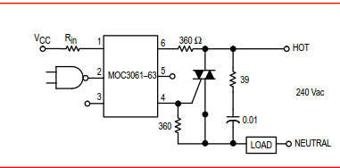

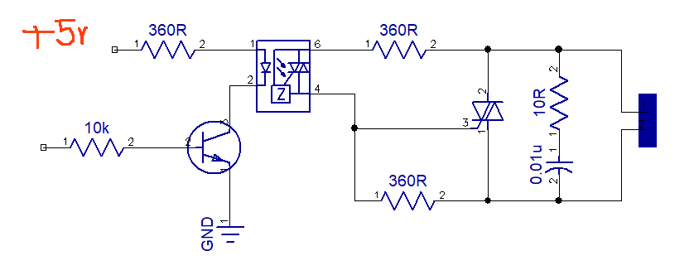
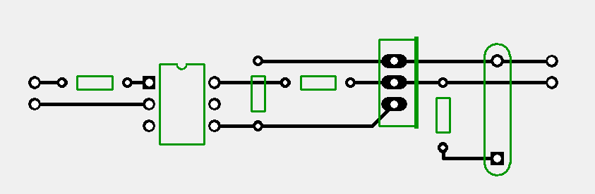
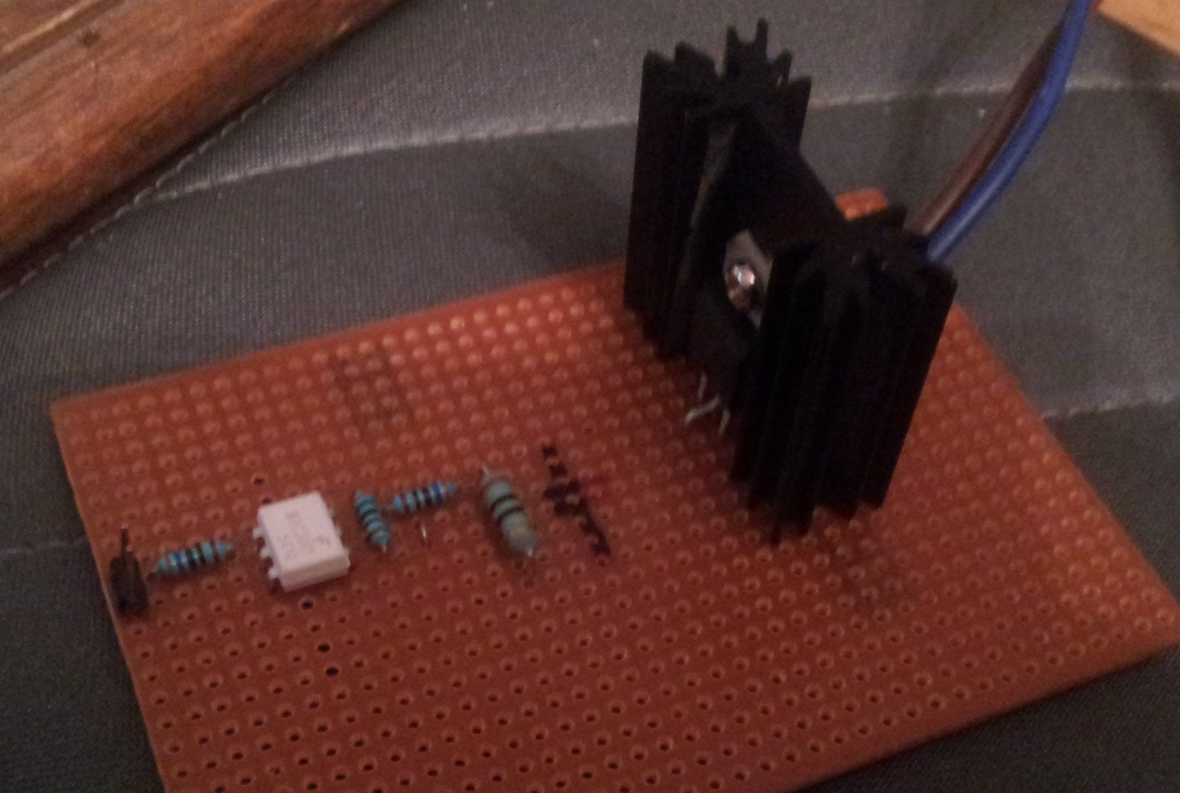
The black mark on the board is where the cap used to go. Don’t know what the big resistor power rating is, but it’s a 10R. the little resistors are 600mW 360R.

